**3.5inch Arduino Display-Mega2560**

|  |  |  |
| --- | --- | --- |
| **语言选择(Other languages)：** | [**中文**](http://www.lcdwiki.com/zh/3.5inch_Arduino_Display-Mega2560) | [**English**](http://www.lcdwiki.com/3.5inch_Arduino_Display-Mega2560) |

**Contents**

 [hide]

* [1Product Picture](http://www.lcdwiki.com/3.5inch_Arduino_Display-Mega2560#Product_Picture)
* [2Product Description](http://www.lcdwiki.com/3.5inch_Arduino_Display-Mega2560#Product_Description)
* [3Product Parameters](http://www.lcdwiki.com/3.5inch_Arduino_Display-Mega2560#Product_Parameters)
* [4Interface Definition](http://www.lcdwiki.com/3.5inch_Arduino_Display-Mega2560#Interface_Definition)
* [5Connect to Arduino](http://www.lcdwiki.com/3.5inch_Arduino_Display-Mega2560#Connect_to_Arduino)
* [6How to use on Arduino](http://www.lcdwiki.com/3.5inch_Arduino_Display-Mega2560#How_to_use_on_Arduino)
* [7Program Download](http://www.lcdwiki.com/3.5inch_Arduino_Display-Mega2560#Program_Download)
* [8Product Documentation](http://www.lcdwiki.com/3.5inch_Arduino_Display-Mega2560#Product_Documentation)
* [9Reference Materials](http://www.lcdwiki.com/3.5inch_Arduino_Display-Mega2560#Reference_Materials)
* [10Common Software](http://www.lcdwiki.com/3.5inch_Arduino_Display-Mega2560#Common_Software)

**Product Picture**

[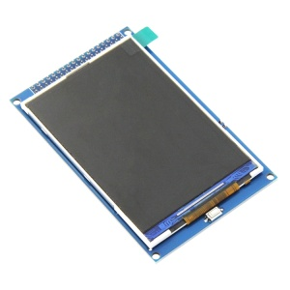](http://www.lcdwiki.com/File:MAR3513-007.jpg) [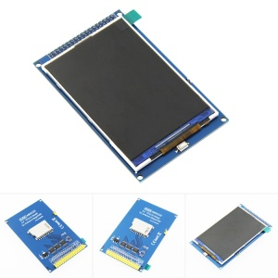](http://www.lcdwiki.com/File:MAR3513-008.jpg)

**Product Description**

* 3.5-inch color screen, support 65K color display, display rich colors
* 320x480 HD resolution for clear display
* Fast transmission with 16-bit parallel bus
* On-board 5V/3.3V level shifting IC, compatible with 5V/3.3V operating voltage
* Support Arduino Mega2560 direct plug-in use
* Provides an Arduino library with a rich sample program
* Easy to expand the experiment with SD card slot
* Military-grade process standards, long-term stable work
* Provide underlying driver technical support

**Product Parameters**

|  |  |
| --- | --- |
| Name | Parameter |
| Display Color | RGB 65K color |
| SKU | MAR3513 |
| Screen Size | 3.5(inch) |
| Type | TFT |
| Driver IC | ILI9486 |
| Resolution | 480*320 (Pixel) |
| Module Interface | 16-bit parallel interface |
| Active Area | 48.96x73.44 (mm) |
| Module PCB Size | 60.30x96.60 (mm) |
| back light | 6 chip HighLight white LEDs |
| Operating Temperature | -20℃~60℃ |
| Storage Temperature | -30℃~70℃ |
| Operating Voltage | 5V/3.3V |
| Power Consumption | TBD |
| Product Weight(Package containing) | about 49(g) |

**Interface Definition**

[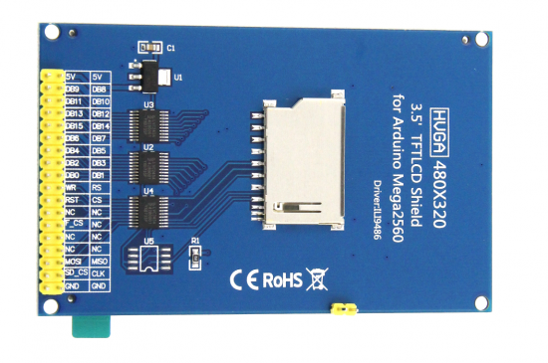](http://www.lcdwiki.com/File:MAR3513-001.png)

|  |  |  |  |  |  |
| --- | --- | --- | --- | --- | --- |
| **Number** | **Module Pin** | **Pin Description** | **Number** | **Module Pin** | **Pin Description** |
| 1 | 5V | Positive power supply | 2 | 5V | Positive power supply |
| 3 | DB8 | 8th bit of data bus | 4 | DB9 | 9th bit of data bus |
| 5 | DB10 | 10th bit of data bus | 6 | DB11 | 11th bit of data bus |
| 7 | DB12 | 12th bit of data bus | 8 | DB13 | 13th bit of data bus |
| 9 | DB14 | 14th bit of data bus | 10 | DB15 | 15th bit of data bus |
| 11 | DB7 | 7th bit of data bus | 12 | DB6 | 6th bit of data bus |
| 13 | DB5 | 5th bit of data bus | 14 | DB4 | 4th bit of data bus |
| 15 | DB3 | third bit of data bus | 16 | DB2 | 2nd bit of data bus |
| 17 | DB1 | 1st bit of data bus | 18 | DB0 | 0 bit of data bus |
| 19 | RS | LCD register / data selection signal  Low level: register, high level: command | 20 | WR | LCD write control signal |
| 21 | CS | LCD screen select control signal, low level enable | 22 | RST | LCD reset control signal, low reset |
| 23 | NC | Undefined, reserved | 24 | NC | Undefined, reserved |
| 25 | NC | Undefined, reserved | 26 | F_CS | SPI flash chip select control signal |
| 27 | NC | Undefined, reserved | 28 | NC | Undefined, reserved |
| 29 | NC | Undefined, reserved | 30 | NC | Undefined, reserved |
| 31 | MISO | SPI bus input signal | 32 | MOSI | SPI bus output signal |
| 33 | CLK | SPI bus clock signal | 34 | SD_CS | SD card select control signal, low level enable |
| 35 | GND | Power ground | 36 | GND | Power ground |

**Connect to Arduino**

|  |
| --- |
| **[无框](http://www.lcdwiki.com/File:MAR3513-010.jpg)** |
| **Arduino Mega2560 direct insertion picture** |

**How to use on Arduino**

* **Step 1: Download the test program**

1. Download the Arduino test program from the [**Program Download**](http://www.lcdwiki.com/3.5inch_Arduino_Display-Mega2560#Program_Download) column
2. For a description of the relevant test procedures, please refer to the test program documentation in the package

* **Step 2: Connect the Arduino development board**

1. Plug the module directly into the Arduino development board ([**Do not plug in?**](http://www.lcdwiki.com/3.5inch_Arduino_Display-Mega2560#Connect_to_Arduino))
2. After the module is plugged in, power on the Arduino board

* **Step 3: Copy the dependent library**

1. Make sure the Arduino IDE is installed on your computer (if it is not installed: [**Arduino IDE download URL**](https://www.arduino.cc/en/Main/Software))
2. After installing the Arduino IDE, you need to copy the dependent library to the Arduino project directory as follows:

(1) Decompress the downloaded test package

(2) Copy the dependent libraries in the **Install libraries** directory in the package (shown below) to the **libraries** folder

of the Arduino project directory （[**Don't know the Arduino project directory?**](http://www.lcdwiki.com/res/PublicFile/Arduino_IDE_Use_Illustration_EN.pdf)）

[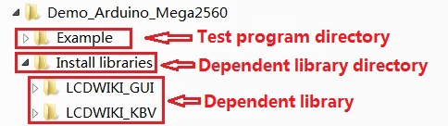](http://www.lcdwiki.com/File:MAR3201-011.jpg)

* **Step 4: Compile and download the program to the development board**

1. Open the sample in the Example directory of the package to test, compile and download（[**Don't know how to compile and download?**](http://www.lcdwiki.com/res/PublicFile/Arduino_IDE_Use_Illustration_EN.pdf)）

* **Step 5: Observe the running of the program**

1. After the program is downloaded, run it directly and observe the running status. If it can be displayed normally, the program runs

successfully, as shown in the following figure (take the colligate_test test program as an example):

[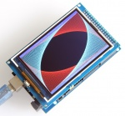](http://www.lcdwiki.com/File:MAR3513-003.jpg) [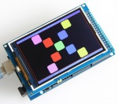](http://www.lcdwiki.com/File:MAR3513-004.jpg)

**Program Download**

* [**3.5 inch Arduino Mega2560 module package**](http://www.lcdwiki.com/res/Program/Arduino/3.5inch/Mega2560_16BIT_ILI9486_MAR3513_V1.0/3.5inch_Arduino_Mega2560_16BIT_Module_ILI9486_MAR3513_V1.0.zip)

**Product Documentation**

* [**3.5 inch Arduino Mega2560 Module User Manual**](http://www.lcdwiki.com/res/MAR3513/3.5inch_Arduino_16BIT_Module_MAR3513_User_Manual_EN.pdf)
* [**3.5 inch TFT Specifications**](http://www.lcdwiki.com/res/MAR3513/3.5inchQD3503728-Spec-V1.0.pdf)
* [**3.5 inch Arduino Mega2560 Module Size Picture**](http://www.lcdwiki.com/images/7/7f/MAR3513-002.png)
* [**3.5 inch QD-TFT3504 TFT LCD Schematic and PCB Package Library**](http://www.lcdwiki.com/res/MAR3513/Altium_3.5_44pin_QD-TFT3504_Package_library.zip)
* [**Driver IC ILI9486 Data sheet**](http://www.lcdwiki.com/res/MAR3513/Datasheet-ILI9486.pdf)

**Reference Materials**

* [**Arduino IDE software use illustration**](http://www.lcdwiki.com/res/PublicFile/Arduino_IDE_Use_Illustration_EN.pdf)
* [**C51 Keil and stc-isp software use illustration**](http://www.lcdwiki.com/res/PublicFile/C51_Keil%26stc-isp_Use_Illustration_EN.pdf)
* [**STM32 keil software use illustration**](http://www.lcdwiki.com/res/PublicFile/STM32_Keil_Use_Illustration_EN.pdf)
* [**PCtoLCD2002 software use illustration**](http://www.lcdwiki.com/res/PublicFile/PCtoLCD2002_Use_Illustration_EN.pdf)
* [**Image2Lcd software use illustration**](http://www.lcdwiki.com/res/PublicFile/Image2Lcd_Use_Illustration_EN.pdf)
* [**Chinese and English display modulo settings**](http://www.lcdwiki.com/Chinese_and_English_display_modulo_settings)

**Common Software**

* [**PCtoLCD2002**](http://www.lcdwiki.com/res/software/PCtoLCD2002.zip)
* [**Image2Lcd**](http://www.lcdwiki.com/res/software/Image2Lcd.zip)

[BACK TO TOP](http://www.lcdwiki.com/3.5inch_Arduino_Display-Mega2560#top)